# Th

Primark

Proposal for Advanced Analytics POC

**O**

**About**

This document details the following:

* Background to proposal
* Advanced data analytics approach
* Key customer behaviour insight identified
* Approach to utilising behaviour insight
* Phase 2 – Trial requirements

**Background**

Think Evolve Solve has been engaged by Primark to develop a proof of concept that demonstrates how advanced analytics can be utilised to drive additional revenue growth. This proof of concept is structured in three phases:

1. **Advanced data analysis** - Think Evolve Solve to analyse data to identify an advanced data analytics application that can be used in a proof of concept trial.
2. **Proof of concept trial** – Set up and run a trial to demonstrate value of the advanced data analytics approach.
3. **Solution deployment** - Decision point on solution deployment.

**Advanced analytics approach**

* **Business understanding** – Met with business to understand current processes, available data and business levers available within the business to drive sales.
* **Data understanding** – For this proof of concept only point of sale data was used.
* **Data modelling** – Data profiling and explorative modelling was completed on POS data to identify trends and patterns within the data.
* **Evaluation** – Insight on customer behaviour was derived from the data modelling phase. This insight was used to design and develop an advanced analytics solution that would be accessible and provide insight that was actionable by the business.

**Key customer behaviour insight**

Our analysis of shopping purchases at the Primark store have shown that we can group shoppers into two behavioural categories. These categories have been labelled ‘**Core product shoppers**’ and ‘**Supporting product shoppers**’.

Core product shoppers exhibit the following characteristics:

* Their purchase basket contains one core product which is a product that has a high value[1] and is selling at a high volume[2]
* Their average basket size is typically 9 products versus the average of 5.2
* The number of high value products sold in addition to the core product in the basket is typically 3
* Core product shoppers make up ~**12%** of the shoppers and generate **24%** of the revenue

Support product shopper exhibits the following characteristics:

* Their purchase basket **does not** contain a core product
* Their average basket size is typically 4.8 versus the average of 5.2
* The number of high value products in the basket is typically 1.2
* Support product shoppers make up ~88% of the shoppers and generate 76% of the revenue

An analysis of the shopper categories identified would suggest the following is the likely behaviour of Primark shoppers:

* When a core product (primary style component product) is released in store shoppers make more purchases than normal to support the effective styling of that product on initial purchase – *this is seen in the core product purchase pattern*
* Shoppers then return to the Primark store after their initial core product purchase to add additional products to their original purchase but they do not include a core product in their basket – *this is seen in the support product purchase pattern*

**Leveraging the customer behaviour insight**

To effectively leverage this behavioural insight the focus is to target the performance of the core product sales to ensure that these generate the expected number of additional high value sales. Focusing the effective merchandising and accessibility of related high value products with a core product should drive additional revenue across both the core product shopper category and the support product shopper category.

An example illustration of this strategy using two core products is detailed below.

**Product 1 – Performing core product**

For product 1 the average number of additional high value products sold is 5. This would be seen as a top performer relative to its peers as typically the number of high value products sold with a core product is on average 3. Action by store manager is to monitor Product 1 performance to ensure that the above average high value purchase rate is maintained.

**Product 2 – Under performing core product**

For Product 2 the average number of additional high value products sold is 1. This would be seen as a weak performer relative to its peers as typically the number of high value products sold with a core product is on average 3. For this product action should be taken to understand why high value products are not being sold with this core product. Typically the root cause may be one of the following:

* **Merchandising:** The core product is not correctly merchandised. For example a blouse that is selling well does not have the correct range of associated high value products that can be used to accompany this purchase. This would indicate a challenge in the initial planning of the merchandising for that high value product.
* **Store layout**: Additional high value products are available in the store and merchandising is correct. The store layout, however, is not optimised to make it easy for a shopper to pick up the additional products i.e. high value items that the customer would like to purchase are not easily accessible in the customer purchase path.
* **Pricing:** A medium priced item is selling extremely well and the potential to increase its price point may exist in order to move it from a low or medium value category item to a high value category item.

**Solution approach**

The Think Evolve Solve solution provides store managers / buyers with access to the following:

* Store wide trends:
  + Total Sales - *Primary measure of success.*
  + Core product average basket value - *Target basket value for core products.*
  + Count of products in the basket - *Target number of products in a basket for core products.*
  + Count of high value products in the basket - *Target number of high value products in a basket for core products.*
* A daily list of the core products in the store that provides details of core products that are performing and underperforming – *Provides target list of core products to be managed*
* Access to core product drill down to understand the following:
  + Key metrics for the core product:
    - Average basket value.
    - Count of products in the basket.
    - Count of high value products in the basket.
  + The typical products found in a basket for this item grouped by high value, medium value and low value – *Provides insight on the contents of typical current basket.*
  + Access to further drill down on the items that have sold with this product ordered by support level – *Provides insight on other products that have sold with this item and their level of association.*
  + What departments in the store a shopper of the core product has also purchased in – *Provides insight on the path through the store that a shopper of the core product has taken.*
  + Recommended high value products based on the customer purchase path and high value products appearing in the current basket – *Utilises data insight (association and store department) to provide recommendations on what other potential high value items could be presented to a customer.*

A sample schematic of how the proposed information could be delivered as a daily dashboard to the business is available in Appendix A. Please note this is for illustrative purposes only.

**Additional data opportunities**

Please note where access to [www.primark.com/en/primania](http://www.primark.com/en/primania) data on styling for products was made available additional significant insight could be provided.

**Phase 2 Trial Requirements**

The objective of the trial is to verify whether the provision of this additional insight if actioned by a store increases overall revenue performance for that store.

Recommended requirements for a suitable trial:

* Review dashboard approach and finalise with business.
* Identify four stores for the trial.
* For each store in the trial identify a partner store that can be classed as similar that can be used as a control store during the trial.
* Proposed duration of the trial three weeks.
* Daily delivery of POS data for each store over a three week period to Think Evolve Solve.
* Each store manager provided with initial training on how to leverage the solution.
* Think Evolve solve to provide portal access to store manager for the solution.
* PDF reports distributed to Floor Managers via email.
* Store manager actively engaged and required to complete daily comment snapshot of actions taken / feedback.
* Store Manager to be available to Think Evolve Solve to discuss insights, effectiveness and benefits.

**Appendix A – Draft dashboard illustration**

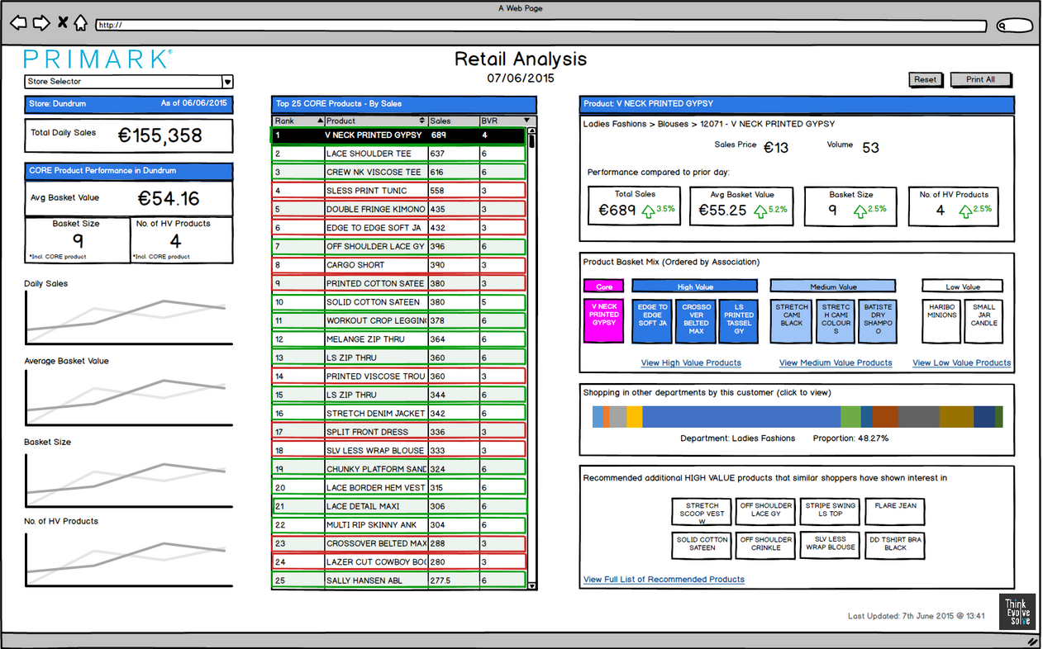

**Why Think Evolve Solve?**

Think Evolve Solve was founded in 2012 to help companies and organisations understand the potential that data has to drive effective decision making and uncover insights about their business. Our team has a passion for technology, learning, creativity and ideas. We create a work environment that is fun, diverse and challenging that ensures we each bring our best talents together to produce outstanding work for our clients.

Our goal is to work with clients who are passionate about growing their business and are looking to the power of data to help them achieve this. Our approach is open and collaborative and we challenge ourselves to ensure that we are not only providing a service solution to our clients but are also developing their knowledge and capabilities.

Our approach to the technical tools is not aligned to any specific technology vendor and we make extensive use of open source software to provide a cost effective approach to providing world class analytics to our clients. This approach ensures our clients get impartial advice with regard to their investment strategy in data tools.

Our team are continuously learning and developing their skills in using the latest tools and techniques in the fast evolving data analytics landscape. Think Evolve Solve provides high quality training and development for our staff to ensure that we have the optimum level of expertise, and latest thinking, to share with our clients.

At Think Evolve Solve we believe strongly that the effective use of data will be the key differentiator that drives the successful companies of tomorrow. We ensure that our clients are positioned to be at the forefront of this trend.

1. High value threshold are derived as part of the solution model
2. High volume thresholds are derived as part of the solution model